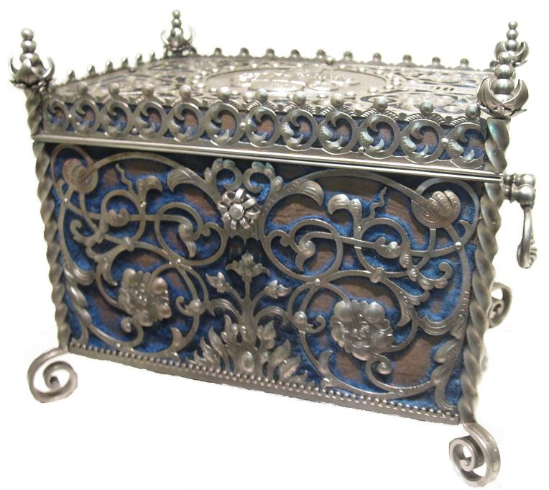

The broken casket

Cut the picture into peaces.
So you can brake and fix the casket many times.
It’s to easy for you?
Try to fix the casket without looking at the little picture above.

Hanns Schell Collection

